Students' perspective...

A PhD student currently working at the Clinical Investigation Centre of the RVC talk about his work:

Does a spoonful of oil help the epilepsy go(es) down?

Current CIC-PhD student Dr. Benjamin-Andreas Berk discussed his research and the path that has brought him here.

The article reviews the professional options that arise from studying a new treatment method for an interspecific chronical neurological disorder and features Benjamin as an example of the interesting work it can lead to.

Dual-degree studied in Biology (BSc, MSc Neurosciences and Behavior) and Veterinary Medicine (DVM) at the University of Leipzig in Germany, Benjamin can be seen as a Lab-Clinic Hybrid. Keeping up his hybrid career stream, application-orientated research in Veterinary Neurology was just the logical consequence for him. In 2016, he began studying at the RVC as an international postgraduate PhD student in Comparative Medicine and Physiology.

Benjamin is now funded by the Hans-Boeckler Foundation to complete his inter-disciplinary PhD supervised by both Prof. Dr. Holger Volk and Prof. Dr. Ludovic Pelligand of the RVC. The focus of this study is to explore the effects of dietary supplements on dogs with idiopathic epilepsy.

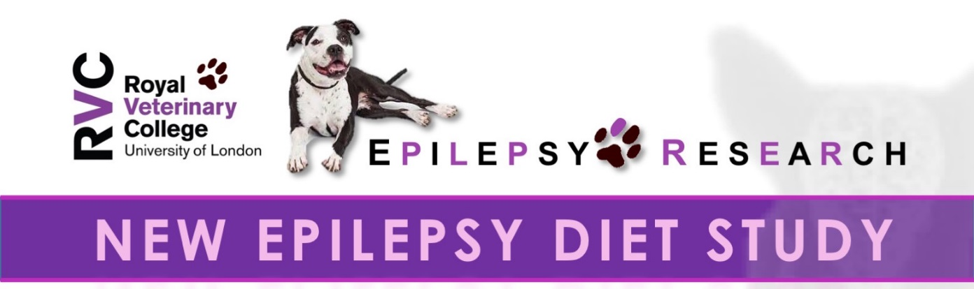

High speed camera capturing spider movement
CAN A SPOONFUL OF OIL HELP THE EPILEPSY GO DOWN?

“It was like my dog had suddenly a thunderstorm in its brain!” – Abnormal neuronal communication in the brain provokes epileptic seizures. The outward effect can vary from uncontrolled movement to complete loss of awareness. An enduring predisposition of generating seizures is called epilepsy. Epilepsy belongs to the most common chronic neurological diseases in humans and dogs. Currently, seizures supressing drugs, also called anti-epileptic drugs or AEDs, represents the most important treatment method in Veterinary Medicine. However, this medication is marked by a fine balance between benefits and harms due to wide range of side effects. As epilepsy is not only affecting on the dogs health, but also welfare, the risk of reduced quality and quantity of life is thought to be secondary to epilepsy. This emphasises the importance of new treatment strategies to improve the welfare of dogs with epilepsy.

( modified from http://screenrant.com/mary-poppins-returns-sequel-release-date-synopsis/ including the song text “A spoonful of sugar” by
Julie Andrews, Marry Poppins, Disney)

Lifestyle factors, particularly the dogs diet, has been shown to have relevant impact on the seizure activity and behaviour of epileptic dogs. Anecdotally, epilepsy support groups commonly report the importance of diets for the control of canine epilepsy. However, there remains a lack of data in veterinary medicine.

A dietary based rise in brain acetone and other ketones has been suggested to evoke antiepileptic properties. Physiologically, this process is stimulated by periods of low food intake (fasting), starvation or restrictive diets. Oral supplementation of medium chain fatty acids (MCT) has been shown to mimic this situation. Resulting therefrom, oil as dietary supplement in specific percentage of the daily calorie consumption might be an effective add-on therapy on seizure control and behavioral comorbidities in dogs.

In an 18-months prospective crossover dietary trial, Benjamin will compare one MCT oil supplemented to the used diet to a standardized placebo oil in chronically antiepileptic drug treated dogs with idiopathic epilepsy. After each period he will collect blood samples, urine and feces, together with data on seizure characteristics and current response on severity of side-effects. Behavioral comorbidities will be additionally assessed by practical tests. This will enable Benjamin to evaluate the dietary effects of medium chain triglycerides (MCT) on the clinical appearance and metabolic profile of dogs with epilepsy.

