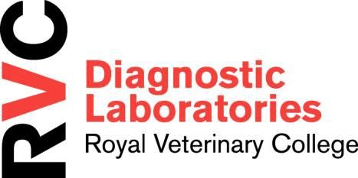
PATHOLOGY & DIAGNOSTIC LABORATORIES THE ROYAL VETERINARY COLLEGE

Hawkshead Lane, North Mymms,
Hatfield, Herts AL9 7TA

Telephone: 01707 666208
Email: diagnosticlabs@rvc.ac.uk

RVC DIAGNOSTIC SERVICE

LABORATORY EXAMINATION REQUEST
(Electronic completion preferred - For more information, contacts etc., please consult our price list)
LAB USE ONLY  | DATE RECEIVED | CHARGE | PATHOLOGY NUMBER
YOUR REF | CLIENT NAME | ANIMAL NAME | DATE COLLECTED  (dd/mm/yy):
SPECIES:  BREED: |  | AGE | SEX
PREVIOUS SAMPLES SENT FROM THIS CASE? |  |  | OUR REF
HAVE YOU SPOKEN TO A MEMBER OF STAFF RE: THIS CASE? |  |  | NAME:
VETERINARY SURGEON NAME:  ADDRESS: |  | SAMPLE TYPE AND SITE
TEL:  EMAIL: |  | EXAMINATION REQUIRED
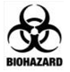

- Please tick box if sample considered a Biohazard (please specify )

HISTORY LESION DISTRIBUTION
