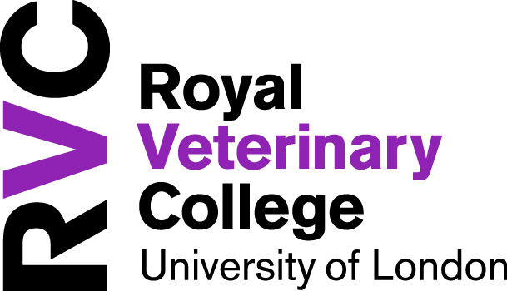 Manager’s Induction Checklist for New Starters

EMPLOYEE NAME |  | MANAGER NAME
DEPARTMENT |  | START DATE
EMPLOYEE NO. |  | PROBATION END

The Manager is responsible for ensuring a full and thorough induction is provided to their new employee. The form should be fully completed and returned to the HR Team. HrAdministration@rvc.ac.uk

BEFORE YOUR NEW JOINER STARTS | ☑ | Date  Completed
Arrange computer and network access (URGENT + Critical to all other systems access)
Agree start time for first day and add to Visitornet
Inform Security Hut at Hawkshead /+ Reception of new employee and date of commencement
Ensure
- desk, chair, lab/office space is in place
- telephone access including mobile phone if applicable
- any specific stationary required
If you are sent an Occupational Health Pre-placement Report ensure any adjustments necessary are implemented – liaise with Employee Relations Manager in HR as necessary
If required, appoint an Induction Buddy (– see guidance in the Toolkit if necessary)
Contact Departmental Safety Supervisor to arrange H&S induction within 2 weeks of joining
Set up as an Agresso user if required (for expenses)
Consider expectations during Induction/probation
- Non-Academic – Consider Induction/Probation objectives for discussion
- Academic – HoD’s PA to set up ICP within the first month ready for approval at next APPP Meeting

DAY 1
Meet new starter at Reception
Introduction to Team and Departmental Administrator
Employee to complete HR Induction videos as soon as possible – details sent via email
IF HR ARE NOT ALREADY IN RECEIPT OF A VERIFIED PASSPORT, WHEN NEW JOINER ARRIVES, AND BEFORE THEY START WORK, EMPLOYEE SHOULD BRING PASSPORT UP TO HR TO VERIFY AND SCAN TO EMPLOYEE RECORD
Employee to complete IT Induction videos as soon as possible – details sent via email
Work shadowing or handover (if appropriate)
Ensure new starter collects security pass (Payroll number will be needed)
Ensure new starter has completed car park pass application form (HH only)
Complete Departmental Induction

Show Facilities (e.g.) location of kitchen, rest areas, lockers, toilets/showers, shuttle bus service, restaurant.

Workstation orientation – undertake DSE assessment

Fire drills and evacuation procedures

Advise on First Aid/Accident Reporting/location of defibrillators

WEEK 1 | ☑ | Date  Completed

Induction/probation meeting to include:
- University Vision, Mission and Values
- Departmental Strategic Plan
- Job Description
- Agree New Starter Objectives Form for Non Academics/Draft ICP for Academics
- Establish expectations on conduct
- Explain the RVC Behaviours Framework and expectations
- Schedule of Review meetings

Expectations - attendance, sickness reporting, lunch breaks, rotas

Departmental Meetings, Systems and Processes including IT policies

Any intranet information specific and relevant to your department

Tour of the Campus
Departmental Administrator session to cover specific requirements
Location of Postroom – opening times and processes
Where to go for equipment, stationery, tools, booking travel
University communications - Town Hall meetings, Intranet and Message of the Day, Classified Adverts etc

WEEK 2
Ensure the whole H&S Induction is completed in full - visit H&S intranet pages for checklist
Ensure HR Induction videos have been completed in full

MONTH 1, 2 AND 3
Hold regular review meetings
Ensure completion of all RVC compulsory training courses:
- Information Safety Awareness
- Equality, Diversity and Inclusion
- Fire Safety
- PREVENT Training : Protection/Safeguarding https://learn.rvc.ac.uk/login/index.php
- Inclusive Leadership (For Managers)
Ensure completion of all Departmental mandatory training courses

Agresso – including demonstration of how to claim expenses

Anything else relevant to your department – insert as required

For Managers only:

Explain the Management Toolkits and the Management Development Programme and provide them with up-coming dates. All Grades 6 & above with appraisal responsibility are automatically enrolled on to the MDP courses.
FOR RESEARCHERS ONLY:-
- Role of the Research Office
- Research Concordat
- Researcher Association

Please fully complete and scan to the HR Team by the end month 3 to confirm completion for the Employees file. HrAdministration@rvc.ac.uk
The Manager is entirely responsible for ensuring the training has taken place; there will be no review or checks by other parties so management accountability is essential.

Manager Signature…………………………………………………………………Date………………………………………..

