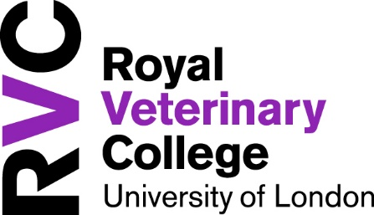

RVC Curriculum Vitae

When submitting a CV for promotion, please highlight any entries achieved since your previous promotion or probation.

RVC Academic Track
(e.g.) 70% teaching etc

- Personal Details
Salutation
Name

- Post Nominals
(Letters placed after your name to indicate positions, degree, qualifications, accreditation.)

- Higher Education (in reverse chronological order)
Dates | Institution

- Higher Education Qualifications/Degrees (in reverse chronological order)
Dates | Qualification | Award

- Other Relevant/Professional/Leadership qualifications
Dates | Qualification | Award

- Job Positions (in reverse chronological order at RVC and previous organisations, recent first)
Dates | Employer | Role | Time in role

- Administrative/Collegiate Roles within RVC (Course director/committee memberships)
Dates | Role

- Professional Society Memberships
Dates | Society Membership

- National/International Awards or Other Distinctions

Dates | Award

- Teaching Delivery (Current Role responsibilities)

- Conference Presentations
Dates | Location | Presentation

- External Committee Posts
Dates | Committee Posts

- Consultancies
Dates | Consultancy Role

- Research Grants and Contracts (personally applied for within the last 3-5 years)
Please include all grants you have submitted, including those that were not funded.
Dates  Start and End | Grant  Title and Grant Awarding body | £ Value  Detail RVC portion, income | Role  PI or CI | Secured:  Successful (Y) OR  Unsuccessful (N)

- Publications
Please indicate your name in bold for all listed publications

  - Refereed Journals

  - Non-refereed Journals

  - Chapters in textbooks

  - Books authored or edited

  - Book Reviews

  - Abstracts

