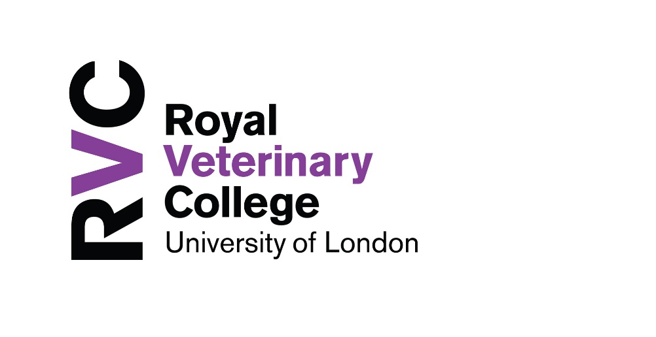
Postgraduate Student Advisors

There are a number of postgraduate student advisors whom students may approach with matters of either academic or personal concern.

- From the 2017-18 academic year onwards, all new students will be assigned a Postgraduate Student Advisor on commencement of their studies.

- It will be the student’s responsibility to make initial contact with their assigned Advisor. It is advisable that this is done within 3 months of their start date at the College.

- Advisors and their students should try to meet annually at the very least, especially around the time leading to the student’s annual appraisal and/or submission of their final thesis.

Please see below details of the advisor that you have been assigned:

Dr Siobhan Abeyesinghe 6947 sabeyesinghe@rvc.ac.uk
Siobhan is part of the Animal Welfare Science & Ethics group at the RVC. She is based in the Pathobiology and Population Sciences (PPS) department at the Hawkshead Campus.
Prof. Brian Catchpole 6388 bcatchpole@rvc.ac.uk
Brian is part of the Comparative Physiology & Medicine research group at the RVC. He is based in the PPS department at the Hawkshead Campus.
Dr Mandi De Mestre 6440 ademestre@rvc.ac.uk
Mandi is part of the Comparative Physiology & Medicine research group at the RVC. She is based in the Comparative Biomedical Sciences (CBS) department at the Hawkshead Campus.
Dr Rob Fowkes 5445 rfowkes@rvc.ac.uk
Rob is part of the Comparative Physiology & Medicine research group at the RVC. He is based in the CBS department at the Camden Campus.
Prof Virginia Luis Fuentes 6333/6820 vluisfuentes@rvc.ac.uk
Virginia is Head of the Cardiology Service and splits her time between clinics in the Queen Mother Hospital in Hawkshead, teaching and research
Prof. Andrew Pitsillides 5245 apitsill@rvc.ac.uk
Andy is part of the Comparative Physiology & Medicine research group at the RVC. He is based in the CBS department at the Camden Campus.
Dr Claire Russell 5409 crussell@rvc.ac.uk
Claire is part of the Comparative Physiology & Medicine research group at the RVC. She is based in the CBS department at the Camden Campus.
Dr Carole Thomas 6211 cthomas@rvc.ac.uk
Carol is part of the Livestock Production & Health research group at the RVC. She is based in the PPS department at the Hawkshead Campus.
Dr Tim West 6891 twest@rvc.ac.uk
Tim is part of the Comparative Physiology & Medicine research group at the RVC. He is based in the CBS department at the Hawkshead Campus.

Although each student has been assigned an Advisor, they are welcome to contact any others on the list below:
Dr Siobhan Abeyesinghe 6947 sabeyesinghe@rvc.ac.uk
Siobhan is part of the Animal Welfare Science & Ethics group at the RVC. She is based in the Pathobiology and Population Sciences (PPS) department at the Hawkshead Campus.
Prof. Brian Catchpole 6388 bcatchpole@rvc.ac.uk
Brian is part of the Comparative Physiology & Medicine research group at the RVC. He is based in the PPS department at the Hawkshead Campus.
Dr Mandi De Mestre 6440 ademestre@rvc.ac.uk
Mandi is part of the Comparative Physiology & Medicine research group at the RVC. She is based in the Comparative Biomedical Sciences (CBS) department at the Hawkshead Campus.
Dr Rob Fowkes 5445 rfowkes@rvc.ac.uk
Rob is part of the Comparative Physiology & Medicine research group at the RVC. He is based in the CBS department at the Camden Campus.
Prof Virginia Luis Fuentes 6333/6820 vluisfuentes@rvc.ac.uk
Virginia is Head of the Cardiology Service and splits her time between clinics in the Queen Mother Hospital in Hawkshead, teaching and research
Prof. Andrew Pitsillides 5245 apitsill@rvc.ac.uk
Andy is part of the Comparative Physiology & Medicine research group at the RVC. He is based in the CBS department at the Camden Campus.
Dr Claire Russell 5409 crussell@rvc.ac.uk
Claire is part of the Comparative Physiology & Medicine research group at the RVC. She is based in the CBS department at the Camden Campus.
Dr Carole Thomas 6211 cthomas@rvc.ac.uk
Carol is part of the Livestock Production & Health research group at the RVC. She is based in the PPS department at the Hawkshead Campus.
Dr Tim West 6891 twest@rvc.ac.uk
Tim is part of the Comparative Physiology & Medicine research group at the RVC. He is based in the CBS department at the Hawkshead Campus.

