**Client Consent for Patient Euthanasia and Aftercare**

Client Surname: Case number: 0

Patient Name: Breed:

Age/DOB: / Sex: Colour:

**PLEASE TICK ONE BOX IN EACH SECTIONS: PART A, PART B AND PART C**

**PART A: Permission for euthanasia**

I am the owner of the above-named animal, and consent for euthanasia to be carried out. *The usual cost of euthanasia is £110 for cats and dogs and £125 for rabbits.*

……………………………………………………………………………………………………………………………………

**PART B: Please indicate below your wishes for your pet’s aftercare – please tick only one box.**

Post-mortem examination – to establish the extent of your pet’s disease progression, you will need to take your pet to our pathology service in Hertfordshire. A report will be available within six weeks. *This is a chargeable service*. Either communal or individual cremation can be arranged following this examination, but pets cannot be released for home burial. **NOTE**: Tissue samples will be retained for further analysis as part of this procedure.

**or**

Donation to the RVC Educational Memorial Programme (EMP) - your pet’s body will contribute to scientific studies and anatomical teaching, which will help our researchers, staff and students gain a greater understanding of diseases that affect companion animals and how we can improve treatment. Individual cremation is not available following this procedure. Your pet will be remembered on our Memorial Wall in the hospital reception. *No additional charge.*

**or**

None of the above.

……………………………………………………………………………………………………………………………………

**PART C: Please indicate below your wishes for your pet’s aftercare – please tick only one box.**

I wish to take my pet home for burial/make my own arrangements. *No additional charge.*

Communal – your pet will be collected by Pet Crematorium Services in Surrey and cremated with other companion animals. A token of the ashes is spread by the crematorium in their memorial gardens. *Additional charge of £48 for pets <25kg and £60 for pets >25kg including body storage and transport*

Individual – your pet will be collected by Pet Cremation Services in Surrey and the ashes returned to us for you to collect approximately one week later. *See part D for options and prices.*

None of the above – I cannot decide now and will telephone the practice within the next 2 weeks to discuss my wishes. *Additional charge of £48 for pets <25kg and £60 for pets >25kg for body storage and administration. If communal cremation/home burial is selected at a later date, no further fees will apply. If individual cremation is selected, the individual cremation fees above will apply, minus the £48/60 already paid. The Beaumont Sainsbury Animal Hospital will make every effort to contact you if you do not advise us of your wishes within 2 weeks. However, if we are unable to make contact with you after this time period, communal cremation will be arranged.*

……………………………………………………………………………………………………………………………………

**PART D: Please indicate below your individual cremation selection – please tick only one box.**

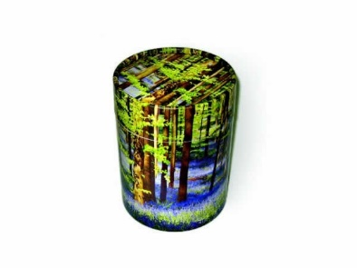Individual cremation costs vary with the size of the pet and the vessel chosen for return of ashes. Prices are inclusive of storage and transport costs.

Ashes returned in a scatter tube – suitable for scattering or burying. *V02 scatter tube small pet £164.40, cat/rabbit £188.40, dog <25kg £230.40, dog >25kg £247.40*

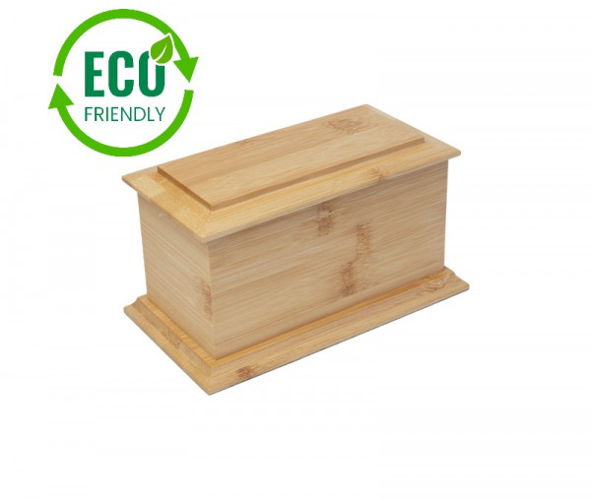Ashes returned in a bamboo casket with engraved nameplate – suitable for keeping. *V05 casket small pet £176.40, cat/rabbit £205.20, dog <25kg £244.80, dog >25kg £261.80* Wording for nameplate below:

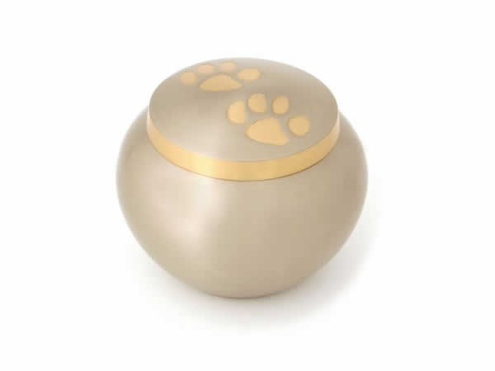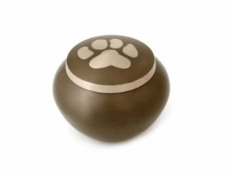-----------------------------------------------------------------------------------------------------

Ashes returned in a slate or pewter urn – suitable for keeping. No nameplate. *V08 slate urn (one pawprint) or V07 pewter urn (2 pawprints) . small pet £216, cat/rabbit £196.80, dog <25kg £246, dog >25kg £320.60*

Ashes returned in a sleeping cat casket – suitable for keeping. No nameplate.V13 black**,** V14 dark, V15 natural. *Cat £290.40*

Ashes returned in a tribute box with photoframe lid V34.

*Small pet £212.40, cat/rabbit £241.20, dog <25kg £280.80, dog >25kg £297.80*

Additional vessel options may be selected from [www.pcsonline.org.uk](http://www.pcsonline.org.uk) – please let the Beaumont Sainsbury Animal Hospital team know the code of your chosen vessel and they will be able to supply the price for individual cremation and return in this vessel.

**Signatures**

Owner/Carer: ________________________________ Name (CAPITALS): _____________________________

Witness: ________________________________ Date: ________________________