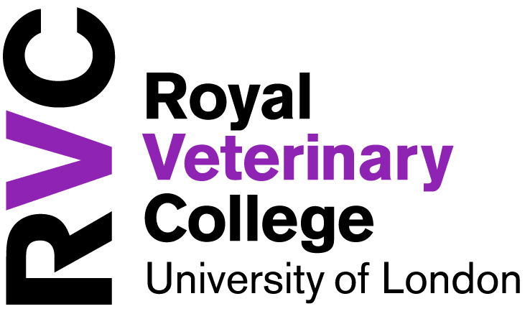THANK YOU FOR MAKING A GIFT TO THE ROYAL VETERINARY COLLEGE.
ANNUAL FUND
DONATION FORM

Name: |  | MAKE THE MOST OF YOUR GIFT  - I am a UK taxpayer and understand that if I pay less Income Tax and/or Capital Gains Tax than the amount of Gift Aid claimed on all my donations in that tax year it is my responsibility to pay any difference. If you are not a taxpayer, do not sign this declaration. If in the future, your circumstances change and you no longer pay sufficient tax, you can cancel your declaration.  - If you are a higher rate taxpayer, you will obtain further tax relief by including donation on your Self Assessment tax return. Since 6th April 2004, you can nominate the RVC to receive the higher tax relief on your tax return.  - You may cancel this declaration at any time by letting us know in writing. Please also notify us of any changes in your name and address whilst this declaration is in force.  I would like to Gift Aid all donations I have made for the past four years and all future donations until I notify you otherwise.
Address:

Our Ref:
Email:  Telephone: |  | Signature:  Date:
I WOULD LIKE MY GIFT TO SUPPORT
Principal’s Priority Fund Attracting the brightest and the best students

Enhancing the student experience Promoting academic excellence

REGULAR GIFT
I would like to make a regular gift of £ a month/quarter/year
PLEASE COMPLETE THE DIRECT DEBIT FORM OVERLEAF
SINGLE GIFT
I would like to make a single gift of £
I would like to make my gift annually (please complete the form overleaf)
I enclose a cheque made payable to the RVC ACT I enclose a CAF Voucher
Please charge my VISA / MASTERCARD / SWITCH / DELTA CARD

NUMBER: EXPIRY DATE: /

SECURITY CODE (last 3 digits on the signature strip): ISSUE NUMBER (SWITCH ONLY):

SIGNATURE: ______________________________________________ DATE: ___________________________

PLEASE RETURN THIS FORM TO THE DEVELOPMENT OFFICE.
Instructions to your Bank or Building Society to pay by Direct Debit
Please fill in the whole form using a ball point pen and send it to:
I would like to support the Royal Veterinary College with a regular gift of:

Please debit my Bank/Building Society account start on: 12th __________ (month)
Royal Veterinary College
Development Office
Hawkshead Lane
North Mymms
Hertfordshire
AL9 7TA

Name(s) of Account Holder(s) |  |  | Instruction to your Bank or Building Society  Please pay the Royal Veterinary College Animal Care Trust* Direct Debits from the account detailed in this Instruction subject to the safeguards assured by the Direct Debit Guarantee. I understand that this Instruction may remain with the Royal Veterinary College Animal Care Trust and, if so, details will be passed electronically to my Bank / Building Society.
Bank/Building Society Number
Bank/Building Society Sort Code |  |  | Signature(s)
 |  |  | Date
Name and full address of Bank/Building Society
To: The Manager Bank/Building Society |  |  | Originator’s Identification
Address
 |  |  | Reference Number (office use only)
Postcode

---------------------------------------------------------------------------------------------

Banks and Building Societies may not accept Direct Debit Instruction for some types of account
This guarantee should be detached and retained by the Payer

Direct Debit Guarantee

THIS GUARANTEE SHOULD BE DETACHED AND RETAINED BY THE PAYEE

- This Guarantee is offered by all Banks and Building Societies that take part in the Direct Debit Scheme. The efficiency and security of the Scheme is monitored and protected by your own Bank or Building Society.
- If the amounts to be paid or the payment dates change the Royal Veterinary College will notify you 10 working days in advance of your account being debited or as otherwise agreed.
- If an error is made by the Royal Veterinary College or your Bank or Building Society, you are guaranteed a full and immediate refund from your branch of the amount paid.
- You can cancel a Direct Debit at any time by writing to your Bank or Building Society. Please also send a copy of your letter to us.

*Direct Debits are processed through the Royal Veterinary College’s charity, the Animal Care Trust, Hawkshead Lane, North Mymms, Hertfordshire, AL9 7TA
Telephone: 01707 666237 Email: act@rvc.ac.uk Website: www.rvc.ac.uk/act Registered Charity Number: 281571

