RVC Student Support Fund
Support Documents Checklist

The RVC Student Support Funds are made available to students each year as a result of generous donations and legacies, and provide support on a discretionary basis. The number of awards granted is limited to the availability of funds.

Student Money Advice Appointments:
If you need assistance completing your application, please arrange an appointment with the Student Money Adviser via the Advice Centre appointment booking system.

Important:
- You must complete all sections of the application form that apply to your circumstances.
- Please ensure you attach copies of all necessary supporting documents to your online application. Failure to submit all the required documents will result in a delay to your application being assessed.
- Processing time varies but usually takes approximately 28 days if all documents are submitted with your application.
- Applications and documents are processed on a rolling basis, so we recommend you submit your application as early as possible.
- Applications must be submitted, in full, before 5pm on Friday 12th July 2024 for continuing students or before 5pm on Friday 31st May 2024 for final year students.

Supporting Documents Required

Income:

UK Undergraduate Students: Student Finance Entitlement Summary 2023/24
☐Log in to your student finance online account, select ‘Undergraduate Applications’ then ‘2023/24 application’ and then ‘Your Inbox’ at the top of the screen. You should then be able to find your entitlement summary letter for the 2023/24 academic year. Examples of pages 1 and 3 of the letter can be seen below:
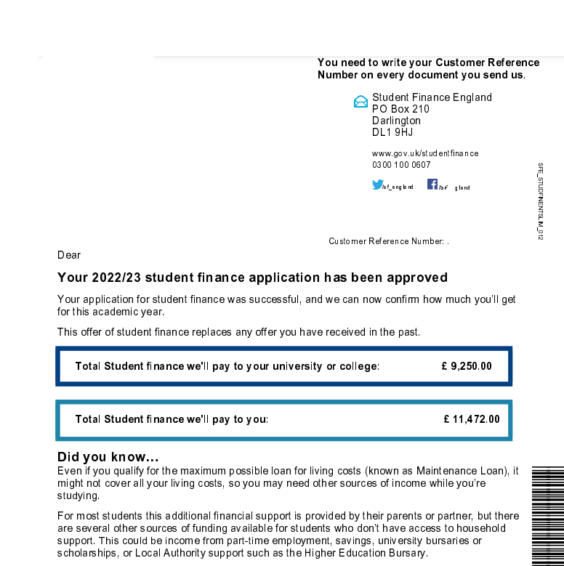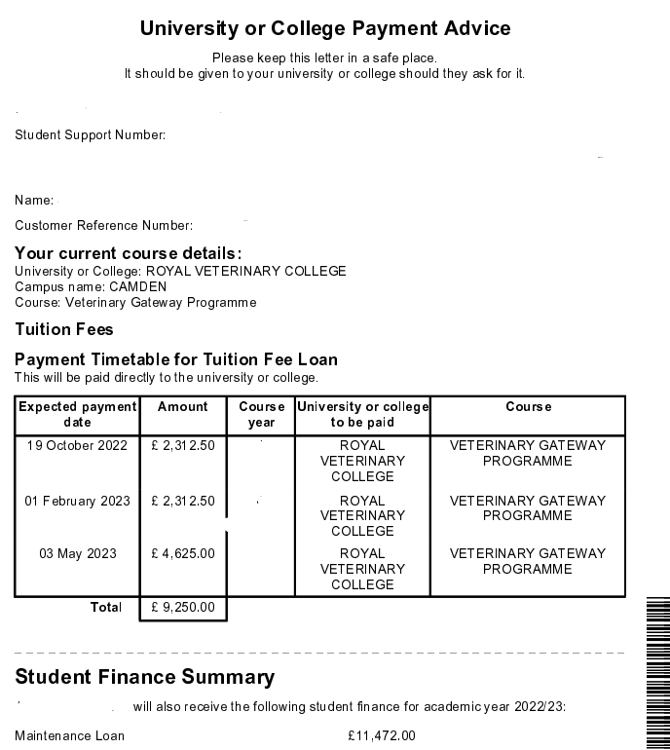

☐RVC Bursary Letter (where applicable). The letter can be downloaded from your student finance account

EU, International and Postgraduate Students:
☐UK Masters Loan Entitlement Letter for 2023/24
☐ Tuition Fee Loan Only Confirmation Letter for 2023/24
☐Stipend Confirmation Letter
☐US Federal Loan RVC Payment Letter for 2023/24
☐Any other Government Loan confirmation letter
☐Funding Confirmation Letter/Statement

Any Other Income: Please provide evidence as appropriate:
☐Student Grants
☐Scholarship
☐Proof of Other Funding

Expenditure:

All Students:
☐Evidence of rent/mortgage. Your current tenancy agreement (for 2023/24) or most recent mortgage statement, with your name, the address of the property and showing how much rent/mortgage you pay per month

☐Bank Statements: Your statements must include your full name, address, starting and closing balance, any other named account holder, and last 4 digits of the account number.
Upload two months bank statements for all your accounts including savings and joint accounts. The statements must cover the last two months up to the date you submit your application (or within two weeks of the date you submit your application).
Please include explanations for all income and spending over £99.
If you can't add this information to your bank statements directly, please include a separate word document explaining any transactions over £99 e.g., student loan, wages, money from parents.
If you bank online, you should be able to download your bank statements from your online account. If you are unsure how to access your bank statements, please visit your banks' website for step-by-step guidance.

☐Council Tax Bill (where applicable)

Students who live with a partner and/or dependent children:
☐Proof of partner’s income e.g. benefits letter, 2 months recent wage slips
☐Bank statements for the last 2 months for joint accounts (see above)
☐Child Benefit Letter or Children’s Birth Certificates
☐Evidence of benefits claimed including Tax Credits or Universal Credit (where applicable) dated within last 12 months

All Students:
☐Any other documents supporting financial circumstances detailed in your application and which you wish to be considered. This could include childcare costs, rent arrears, details of unexpected costs, information from Police if you have been a victim of a crime, other debts.

