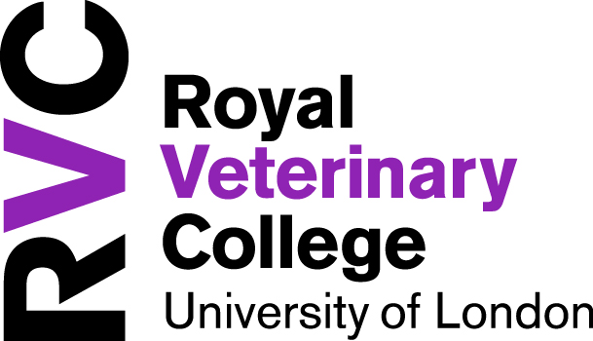

RVC EMS+ Award Application

Name

Course & year

E-mail Address |  | Telephone number
Name of contact person at Placement
Placement Name and Address

Proposed date of placement (please estimate if not yet confirmed) |  | Length of placement

Has your placement already been approved by the Placements Team? YES/NO
If so please attach your e-mail confirmation, if not any award made will be subject to approval

Are you a member of a current SU Club or Society relevant to this EMS? YES/NO
If yes please give the names of the Clubs or Societies________________________________
___________________________________________________________________________

Have you applied/are you planning to apply for any other funding for this placement? YES/NO
If yes please give details_______________________________________________________
___________________________________________________________________________

Remember that this funding is available for aspirational placements only.
Please consider this when completing the following questions and think about how it will shape your career, why is it above and beyond other placements
and how it will help you personally.
1. Please describe the placement opportunity and how it fits with your personal aspirations? (min 250 words)

2. What learning objectives will you take from this placement? What will you gain and why will it be important for your future career?

3. Would an award be necessary for you to be able to participate in this placement?
If the cost of the placement is greater than the award made, how do you plan to cover the shortfall? Please give details of any costs already secured:

Costs

Estimated travel costs of placement | £
Estimated accommodation costs | £
Estimated other costs (please list & describe) | £
Total cost of placement | £

Declaration:

- I agree that my application and all information submitted with it can be reviewed by RVC staff and members of the RVC EMS+ Awards Panel.
- I confirm that the information given in this application is true and correct to the best of my knowledge.
- I accept that the decision of the Panel is final and understand it is not possible for applicants to appeal the decision of the panel. I understand it is not possible for the panel to give individual feedback due to the large number of applications received.
- I confirm that if I am successful I will submit a report to the EMS+ scheme according to the guidance given within a month of the end date of the placement.
- If I am granted an award I give permission to the RVC and/or RVC Animal Care Trust to use my report and any photos I submit for internal and external reporting processes, fundraising and marketing both online and offline.

Name

Signature

Date

Data Protection - The information you provide will be treated confidentially and will be used by the RVC Panel in order to make a funding decision. For more information on how we use your data, please refer to our Privacy Notice, which can be found here.

Please send this completed application to Joyce Fenner, Grants and Legacies Administrator, External Relations, Hawkshead Campus. Email to: jfenner@rvc.ac.uk

If you are experiencing financial difficulties, please contact the Money & Welfare Adviser: moneymatters@rvc.ac.uk.

