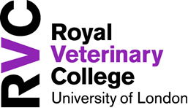

Assistance Animal Agreement

As the Handler/user of a visiting assistance animal, I confirm that I have read the RVC Code of Conduct regarding dogs on campus and understood the following statements:
- I have provided a copy of the animal’s current vaccination and insurance certificates.
- I understand that my animal must wear a lead, collar, cape or other appropriate visible identification, which identifies in writing that the animal is an assistance animal.
- My animal is house trained, well groomed, odour free and not infected with external parasite (ticks, fleas or lice).
- I understand that my animal must be on a lead at all times while on campus and additionally must be controlled by verbal commands.
- I understand that I am responsible for the sanitary disposal of my animal’s waste while on campus.
- I understand that my animal will not be allowed in restricted areas as outlined in the Code of Conduct.
- I understand that I am liable and responsible for my animal’s behaviour and activities while on campus, including property damage.
- I understand that I must follow all procedures and requirements for an animal user/owner as outlined in the Code of Conduct.

Handler/Users Name

Handler/Users Signature

Date

University Approved Signature

Position

Department

Date

Please Email this form to: Disability@rvc.ac.uk

