APPENDIX B
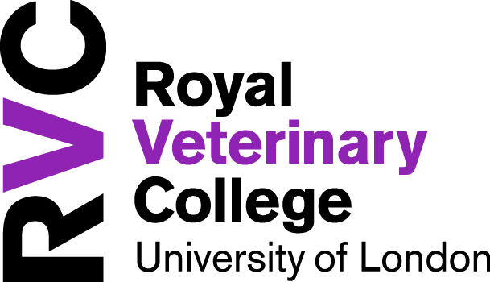

APPLICATION FORM FOR ADOPTION LEAVE
AND PAY - UK

Please read the College’s Adoption Leave Guide, and discuss your situation with the HR Department before completing this form. Correct completion of this form will help to protect your entitlement to adoption leave and pay, as well as your right to return to work.
Name:……………………………………………. Department:………………………..
Date my child is expected to be placed with me for adoption:…………………………….
Proposed adoption leave start date:…………………………………………………………

Please tick the statements which apply to you
  - I confirm that I have received notification of a match with my child for adoption
  - I confirm that I have informed my line manager that I am adopting
  - I confirm that I wish to retain my right to return to work
  - I am certain that I will not be returning to work after my adoption leave.
  - I will give the College at least 8 weeks’ notice if I intend to change my return to work date
  - I have enclosed with this form my original ‘Matching certificate’ (photocopies will not be accepted)
Declaration:
I have read the College’s Adoption Leave Guide, and I agree to the following:
- I will reply to all correspondence from the College within the required time. I understand that I may lose my right to return to work if I do not do so.
- I understand that the Occupational Adoption pay is paid on the condition that I return to work for at least 3 months. I agree to repay this money if I do not return to work for 3 months. I also agree that the College can recover any monies due from any other payments owed to me (eg: for unused annual leave)
Signature:…………………………………………………….Date:…………………………………
Please return this form to HR no later than 7 days after the date on which notification of a match with your child has been provided by the adoption agency.

