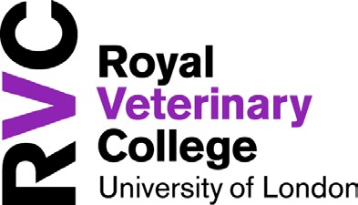

COVID-19/CORONAVIRUS - SELF DECLARATION FORM

Please use this form if you are absent from work as a result of:

- Having any form of COVID-19/Coronavirus sickness symptoms
- Having tested positive for COVID-19/Coronavirus

By completing this form, staff with symptoms or diagnosed with Coronavirus, will not be required to complete the normal college sickness form.

Please complete in block capitals

Name
Job Title
Staff no.
Department
Department Section
Line Manager

Date of First Day of Absence |  | Anticipated Last Day of Absence
Anticipated Return to Work Date |  | No. of days/weeks absence

DETAILS
I am required to self-isolate for the following reason:
☐ I have tested positive for COVID-19

☐ I have symptoms of coronavirus illness (COVID-19), - i.e.: a new persistent cough and/or high temperature, so I am required to isolate for 7 days

DECLARATION
I declare that the information I have provided above is factually correct. I understand that to give false or misleading information can result in disciplinary proceedings.

Signature |  | Date
Line Manager’s Signature |  | Date

Please return the completed form to Human Resources. hr@rvc.ac.uk

