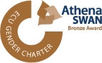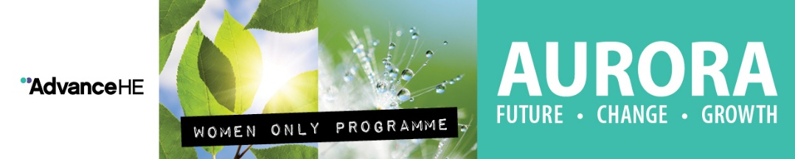

AURORA- Process and Criteria 2021

Aurora is a women-only leadership development programme run by Advance (HE) former Leadership Foundation for Higher Education The programme provides the skills they need to support their career development. It is a partnership initiative bringing together leadership experts and higher education institutions to take positive action to address the under-representation of women within their institutions.

The RVC has highlighted its commitment through the Athena SWAN Action Plan and the Gender Pay Gap reports to address under-representation of female staff within senior grades. The College will be offering six places for female staff to participate in the leadership development programme. Further details of the Aurora programme can be found on the following link: https://www.lfhe.ac.uk/en/programmes-events/equality-and-diversity/aurora/index.cfm

Who is Aurora for? What are the expectations?

- Aurora is aimed at all female staff (RVC grades 7 and 8) working in a university, college or related organisation who would like to develop and explore issues relating to leadership roles and responsibilities.

Participants should be committed to developing and enhancing their career and will be required to:

- Attend each of the five development days, and the action learning set days organised by participants in their assigned groups; (see next page for dates);
- Undertake self- directed learning throughout the programme, aligned with developing interests such as;
- Commit to work with a mentor which will be provided by the College
(participants may wish to choose their own mentor);
- Act as a mentor for future Aurora participants;
- Commit time after the programme to support the College Equality and Diversity lead and the Champions in promoting women’s leadership.

Dates for 2021

There will be two cohorts running during the 2021 with a total of six female staff selected to attend the programme.

Cohort 1: online | Date
Introductory Webinar | 17 February 2021 (10am - 12 noon)
Identity, Impact and Voice | 24 February 2021 (10am – 3pm)
Politics and Influence | 24 March 2021 (10am -3pm)
Action Learning Set 1 | 21 April 2021
Core Leadership Skills | 12 May 2021 (10am – 3pm)
Adaptive Leadership Skills | 23 June 2021 (10am -3pm)
Action Learning Set 2 | 7 July 2021

Cohort 2: online | Date
Introductory Webinar | 19 March 2021 (10am -12 noon)
Identity, Impact and Voice | 26 March 2021 (10am -3pm)
Politics and Influence | 7 May 2021 (10am -3pm)
Action Learning Set 1 | 21 May 2021
Core Leadership Skills | 11 June 2021 (10am – 3pm)
Adaptive Leadership Skills | 2 July 2021 (10am – 3pm
Action Learning Set 2 | 16 July 2021

Selection Criteria

Applications will be assessed against the following criteria:
Prerequisites:
- Female member of staff in grades 7or 8,
- Up to date with compliance training
- Beyond first year of probation
- Line manager support
Criteria:
- Career aims relate to leadership (in the medium and longer term); the career path is logical and coherent and includes key steps from the medium-term to the longer-term to support the leadership journey; evidence of motivation for leadership role;
- Clear relationship between the women-only Aurora programme and the support required to achieve the identified career aims in leadership; benefit to the RVC of supporting this individual;
- Evidence of commitment to development; development in leadership influencing /engaging / motivation skills- as well as in profession/ specialism; evidence of reflective practice and changes made as a result of development;
- Evidence of understanding and practice of influencing /engaging / motivation skills;
- Evidence of awareness of challenges in RVC women’s progress and how a network of Aurora alumni might help address this;
- Commitment to comply with the programme requirements, and to ‘give back’ and support women’s leadership in the RVC after the programme including supporting work of the Equality and Diversity Committee to advance the equality agenda.

Application process/timeline

- Applications open: 9 December 2020
- Application closes: 8 January 2021
- Panel meets: week commencing: 18 January 2021
- Notification of application: week commencing 25 January 2021
- First Spring Cohort: 17 February 2021
- Second cohort: 9 March 2021

Selection Panel

Composition of the selection panel is:

- A member of the Principal’s Advisory Group
- Chair of Equality and Diversity Committee
- Diversity and Inclusion Manager
- Staff Development Manager
- Former Aurora Participate
Application Form: Aurora Programme 2021
Score /18

Name:

Job Title:

Department/Grade:

Preferred Cohort | February/March 2021 or either (please circle preference)

Essential Requirement
To apply for a place on the Aurora programme you will have to satisfy the criteria outlined below:
Are you up to date with your compliance training: Yes No
Are you beyond your 1st year of probation by 31st January 2021: Yes No

- Please tell us your medium and long term career goals, and what motivates these aspirations and how these support your leadership journey. Put this in the context of your career journey to date.

- Why do you wish to participate in the Aurora Leadership Programme and how will the RVC benefit if you do?

- Please give examples of recent (last 2 years) activities you have undertaken to support your professional development and what you have learned from these.

- Please provide two examples of when you have led and/or successfully influenced, motivated and engaged others?

- What do you see as the challenges to Women’s progression in the RVC and what contribution could a network of Aurora alumni make to overcome these?

- Please confirm that you are able to comply with the programme requirements: attendance at workshops and an action learning set; meetings with a mentor; and e-learning on leadership. Please state how you are willing to give your time post programme to support women’s leadership development and work with the Equality and Diversity Committee (including local E&D Champions) to advance gender equality within the College.

Could you send your completed application form to: fnazirbhatti@rvc.ac.uk by no later than 8th January 2021.

