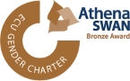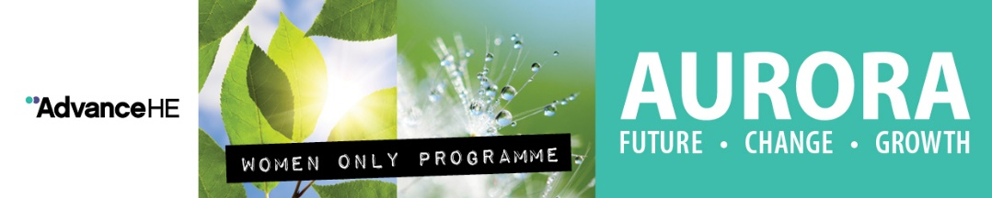

AURORA- Process and Criteria 2018/19

Aurora is a women-only leadership development programme run by Advance (HE) former Leadership Foundation for Higher Education The programme provides the skills they need to support their career development. It is a partnership initiative bringing together leadership experts and higher education institutions to take positive action to address the under-representation of women within their institutions.

The RVC has highlighted its commitment through the Athena SWAN Action Plan and the Gender Pay Gap report to address under-representation of female staff within senior grades. The College will be offering six places for female staff to participate in the leadership development programme. Further details of the Aurora programme can be found on the following link: https://www.lfhe.ac.uk/en/programmes-events/equality-and-diversity/aurora/index.cfm

Who is Aurora for? What are the expectations?

- Aurora is aimed at all female staff (RVC grades 7 and 8) working in a university, college or related organisation who would like to develop and explore issues relating to leadership roles and responsibilities.

Participants should be committed to developing and enhancing their career and will be required to:

- Attend each of the four development days, and the action learning set day organised by participants in their assigned groups; (see next page for dates);
- Commit to support College Equality and Diversity Champions in promoting women’s leadership;
- Undertake self- directed learning throughout the programme, aligned with developing interests such as;
˃ Commit to work with a mentor which will be provided by the College
(participants may wish to choose their own mentor);
> Willing to act as Aurora Programme mentor for future participants.

Dates and Venues for 2018/19

There will be two cohorts running during the 2018/19 academic year with a total of six female staff selected to attend the course. Three places for autumn and three places for spring, based for the London venue.

Location | Identity, Impact and Voice | Power and Politics | Action Learning Sets* | Core Leadership Skills | Adaptive Leadership Skills
London (autumn) | Tuesday 30 October 2018 | Tuesday 27 November 2018 | Tuesday 11 December 2018 | Tuesday 22 January 2019 | Tuesday 26 February 2019
London (spring) | Friday 8 March 2019 | Friday 5 April 2019 | Friday 3 May 2019 | Friday 7 June 2019 | Friday 5 July 2019

Selection Criteria

Applications will be assessed against the following criteria. In order to be eligible, you should:

- Open to all female staff within grades 7or 8,
- Explain your career aims with reference to leadership (in the medium and longer term). The career path should be logical and coherent and include key steps from the medium-term to the longer-term career,
- Be able to demonstrate commitment to your own personal development by providing examples of when you have sought out development opportunities to further enhance your leadership skills and /or influencing /engaging / motivating others,
- Be able to explain how Aurora’s aims and programme will support you to achieve your career aims in leadership and/or influencing/engaging/motivating others and will improve your existing skills/capabilities/experience and networks,
- Be able to demonstrate why now is a good time to participate in the Aurora programme considering current job role, performance, development plans,
- Two examples of what you did to lead and/or successfully influence, motivate and engage others,
- You also need to have the support of your line manager for this application,
- We will also consider the spread of applications across the College to ensure women of a variety of roles and departments are given opportunities.

Application process / timeline

- Applications open: 23 July 2018
- Application closes: 9 September 2018
- Panel meets: week commencing10 September 2018
- Notification of application: week commencing 17 September 2018
- First London (Autumn) cohort: 30th October 2018
- Second London (Spring) cohort: 8 March 2019

Selection Panel

Composition of the selection panel is:

- A member of the Principal’s Advisory Group
- Chair of Equality and Diversity Committee
- Equality & Diversity Manager
- Staff Development Manager

Application Form Aurora Programme 2018/19

Name:

Job Title:

Length of Time in Current Post:

Department:

Line Manager:

Access Requirements:

Application for autumn or spring cohort

Note: Please return your application form to Ferhat Nazir-Bhatti, Equality and Diversity Manager on fnazirbhatti@rvc.ac.uk by Sunday 9 September 2018.

- Please summarise your current role and what are your medium and long term plans?

- Please give examples of recent (last 2 years) activities you have undertaken to support your professional development?

- How will this programme support your career development?

- Why do you wish to participate in the Aurora Leadership Development Programme and why is now a good time for you to do so?

- Please provide two examples of when you have led and/or successfully influenced, motivated and engaged others?

- Please confirm that you are able to comply with the programme requirements: attendance at workshops and an action learning set; meetings with a mentor, working with Equality and Diversity Champions to promote women’s leadership.
Please sign to declare all information is accurate and you have your Line Manager’s approval to participate on the Aurora Programme.

Signature:_____________________________________________

