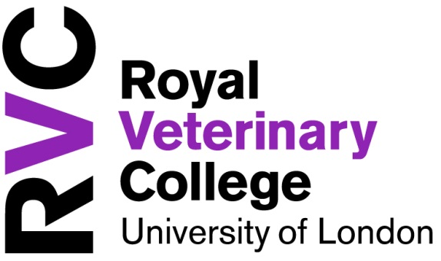
PROGRAMME SPECIFICATION
1. Applies to cohort commencing in:
2. Degree Granting Body | Normally the University of London
3. Awarding institution | Normally The Royal Veterinary College, except for e.g. Distance Learning courses run through the University of London Worldwide
4. Teaching institution | Normally the RVC and any partner with which we deliver the course jointly, e.g. LSHTM, IoZ
5. Programme accredited by | e.g. Royal Society of Biology, RCVS
6. Name and title | e.g. Master of Science in Veterinary Epidemiology
7. Intermediate Awards | e.g. Postgraduate Diploma in Veterinary Education
8. Course Management Team | e.g. Course Director, Year Leaders
9. FHEQ Level of Final Award | See the Framework for Higher Education Qualifications of UK Degree-Awarding Bodies here https://www.qaa.ac.uk/quality-code/qualifications-and-credit-frameworks
10. Date of First Intake
11. Frequency of Intake
12. Duration and Mode(s) of Study | e.g. three years, full time
13. Registration Period (must be in line with the General Regulations for Study and Award)
  Full Time |  | Part Time
  Minimum | Maximum | Minimum | Maximum
14. Timing of Examination Board meetings
15. Date of Last Periodic Review
16. Date of Next Periodic Review
17. Language of study and assessment
18. Entry Requirements | Hyperlink to definitive current entry requirements on http://www.rvc.ac.uk/search/study?q=entry+requirements
19. UCAS code | To be advised by Head of Admissions as part of course development process
20. HECoS Code | To be advised by Student Records and Planning Officer as part of course development process
21. Relevant QAA subject benchmark | (if applicable)
22. Other External Reference Points

23. Aims of programme
A concise, overall statement of the educational purposes of the programme. E.g.
- To offer a high quality course incorporating extensive research experience, in which students are challenged by, and stimulated to challenge, accepted wisdom in all fields of biological science;
- To prepare graduates for a PhD or careers in academic and commercial research, and in a range of graduate careers that involve the management and welfare of companion, farm, laboratory, working and wild animals.
24. Overall Programme Level Learning Outcomes - the programme offers opportunities for students to achieve and demonstrate the following learning outcomes. Learning outcomes should be specified for all intermediate awards as well as for the terminal award.
E.g. On successful completion of the Postgraduate Diploma course, students will be able to: |  | Modules in which each learning outcome will be developed and assessed:
- demonstrate a profound understanding of epidemiology as the study of patterns and factors that affect health and welfare in animal and human populations;
- select an appropriate study design when confronted with an epidemiological research question and develop a study protocol capable of answering the research question;
- enter and manage computerised epidemiological data and carry out appropriate statistical analyses;
- assess the results of epidemiological studies (their own or other investigators’), including critical appraisal of study question, study design, methods and conduct, statistical analysis and interpretation;
- continue to develop independent and lifelong learning skills to promote their own personal and professional development as veterinary epidemiologists and leaders
On completion of the MSc course, students will additionally be able to:
- Carry out an independent research project, write the results in the form of a journal article and defend their project orally
25. Teaching/learning methods |  | Approximate total number of hours
Lectures
Practical Classes
Clinical Rotations
Seminars
Tutorials
Directed Learning Sessions
26. Assessment methods |  | Percentage of total assessment load
Coursework
Written Exams
27. Feedback
Describe how and when students will receive feedback, individually or collectively, on their progress in the course overall
28. Programme structures and requirements, levels, modules, credits and awards
 | Module Title |  | FHEQ Level | Credits | Compulsory or optional
Year 1, Term 1 | Module titles to be hyperlinked to the definitive module outline
etc
29. Work Placement Requirements or Opportunities
30. Student Support |  |  | http://www.rvc.ac.uk/study/support-for-students
31. Assessment
Hyperlink to Course Assessment and Award Regulations https://www.rvc.ac.uk/about/the-rvc/academic-quality-regulations-procedures

Version Number | Amended by | Date

