WRITING OF EXTernal examiners annual report
Notes for External Examiners on how to submit their annual report within the online system

External Examiners are required to submit annual report via a web form on our External Examiner Report System at https://exr.rvc.ac.uk/
using their credentials provided at the start of their appointment.
External Examiners can choose to submit individual reports or work collaboratively to submit one report on behalf of a team of External Examiners for one course/year of the course. In case of Collaborative report, External Examiners need to decide among themselves who will act as a Lead Examiner to enter the final report. This needs to be confirmed with the Exam Officer at the Board of Examiners.

Following Board of Examiners, External Examiners will be emailed a link to the online system, log in details with a short instruction on how to submit the report.*** Once the collaborative report is entered by the Lead Examiner, Collaborating examiners will be emailed and asked to approve it.

Here are some key facts:

- For individual report you will be asked to submit a report within 2 weeks from the Exam Board
- For collaborative report, the lead examiners will have 1 week to write and submit the report and collaborating examiner(s) will have 1 week to approve it. ***Please note the following - At the approval stage, should one or more collaborating examiners disagree with any of the comments written by the lead examiner, they will be able to comment in a relevant sections of the online report. The lead examiner will be notified of this and will be able to edit the report while taking these comments into consideration. Please note that the system will allow editing of the report only once. If collaborating examiner(s) continue to disagree(s) with the final report and do not wish to approve it, they will be offered to withdraw from collaboration and asked to submit their individual report.***

After the report has been submitted, the External Examiners will receive an email with a claim form for fees and expenses and instructions on how to claim these.

Please see below some further instructions with screenshots.

For any queries, please contact externalexamining@rvc.acuk or Senior Academic Quality Officer Ana Filipovic afilipovic@rvc.ac.uk
July 2022
For Collaborative Report:
Personalised Portal – Name of External Examiner will appear here!
Instructions for the Lead Examiner:
Home page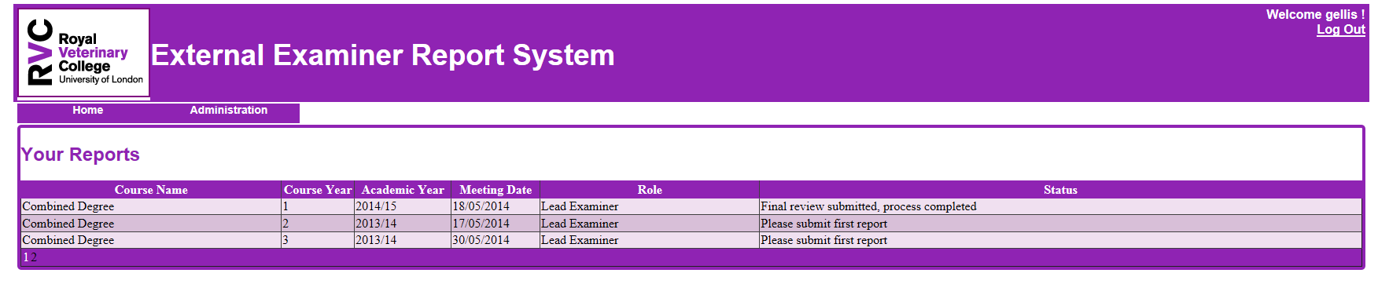
If you are acting as External Examiner for more than one course, please select the course you are writing the report for. Otherwise, if you have one course only, click on the title of the course.

Instruction Tab – please pay attention to these, specifically with regards to confidentiality when writing the report!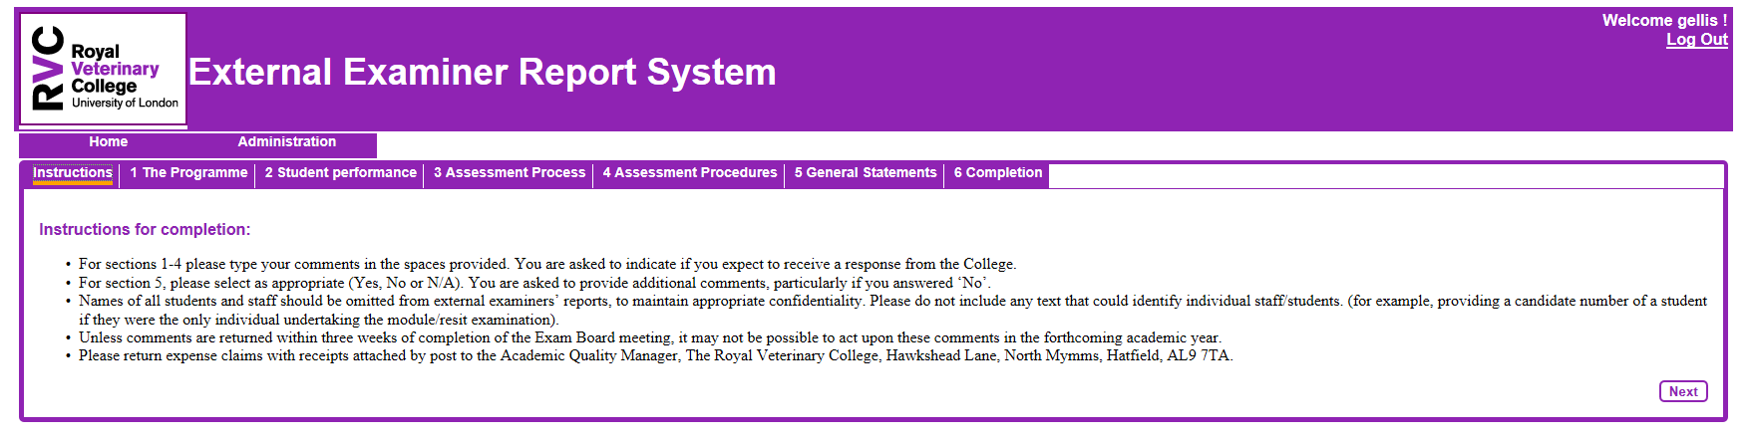
Once you have read the instructions, please click ‘Next’. This will take you to the report form.

Enter the report! There are 6 different sections of the report form, please navigate through these by using the ‘Next’ button at the end of each page or simply by clicking on the tab buttons in the top row. 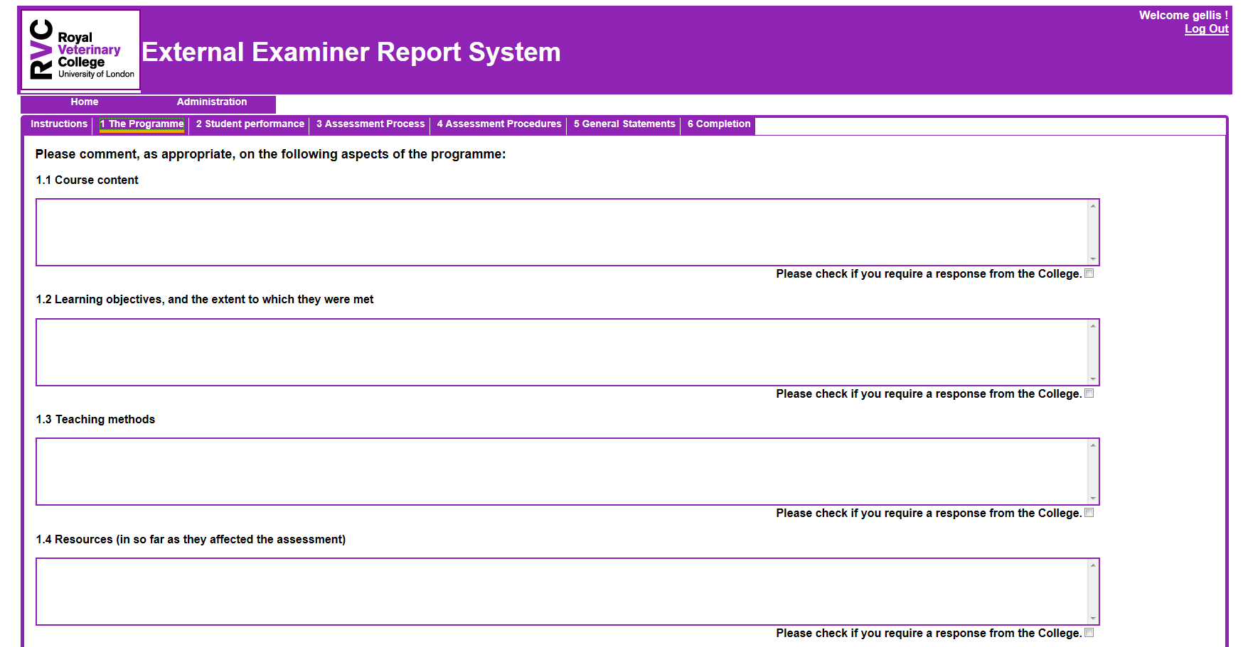

Final page of the report!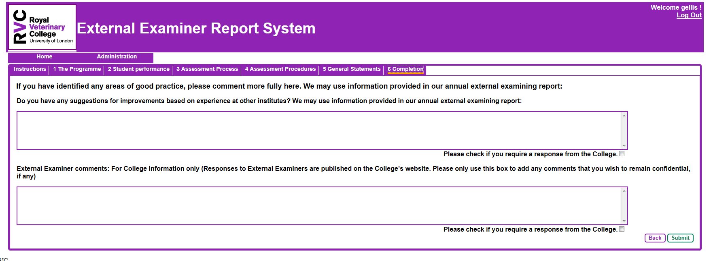
Once you have entered the report, click Submit! You will receive a pop up below!

Pop up when ‘Submit’ clicked!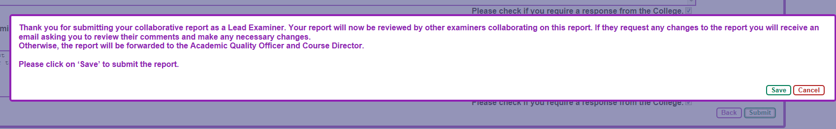
Click ‘Save’ to submit the report!
Instructions for the Collaborating Examiner – Review Report - Home Screen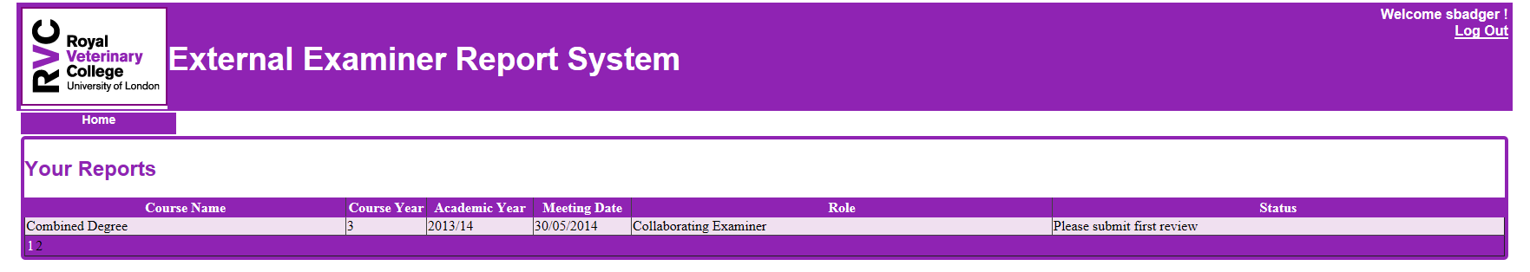
If you are acting as External Examiner for more than one course, please select the course you are writing the report for. Otherwise, if you have one course only, click on the title of the course.
Personalised Portal – Name of External Examiner will appear here!
Instruction Tab – please pay attention to these, specifically to the first bullet point! Please note that the report can be changed once only following collaborating examiner’s comments. If after this, you still do not wish to approve the final report, you will be offered to complete your individual report. 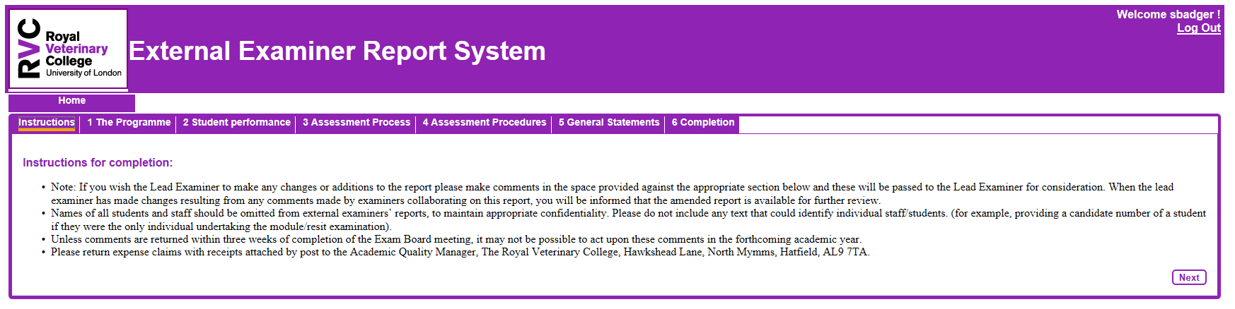

Review Report – First part of report (allowing Collaborating Examiners to enter their comments).
*There are 6 different sections of the report form, please navigate through these by using the ‘Next’ button at the end of each page or simply by clicking on the tab buttons in the top row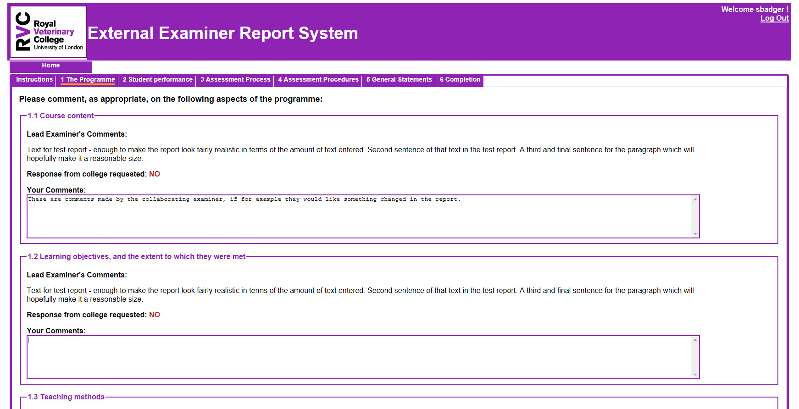

Review Report – Final part of report! 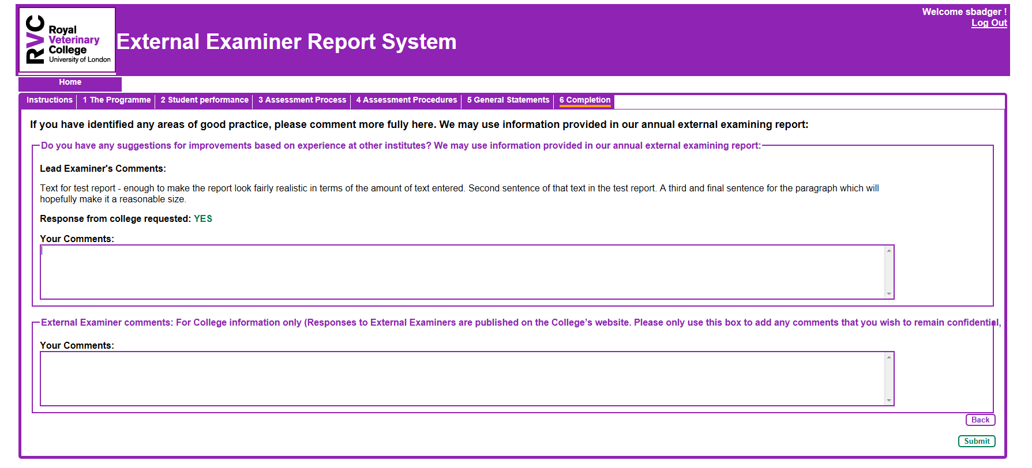
Once you have reviewed the report, click Submit! You will receive a pop up below!
Collaborating Examiner – Review Report – Pop up when submit button clicked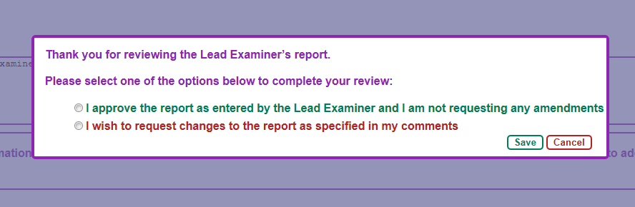
Click ‘Save’ to submit the report!
Personalised Portal – Name of External Examiner will appear here!
Individual Examiner – Home Page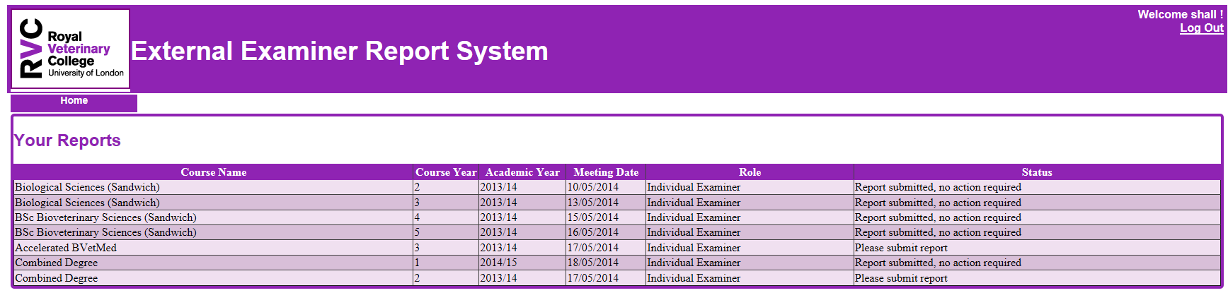
If you are acting as External Examiner for more than one course, please select the course you are writing the report for. Otherwise, if you have one course only, click on the title of the course.
Instruction Tab – please pay attention to these, specifically with regards to confidentiality when writing the report!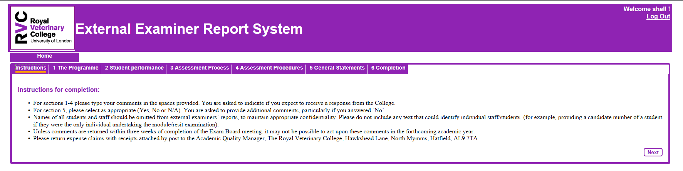
Once you have read the instructions, please click ‘Next’. This will take you to the report form.

Individual Examiner – write your report! There are 6 different sections of the report form, please navigate through these by using the ‘Next’ button at the end of each page or simply by clicking on the tab buttons in the top row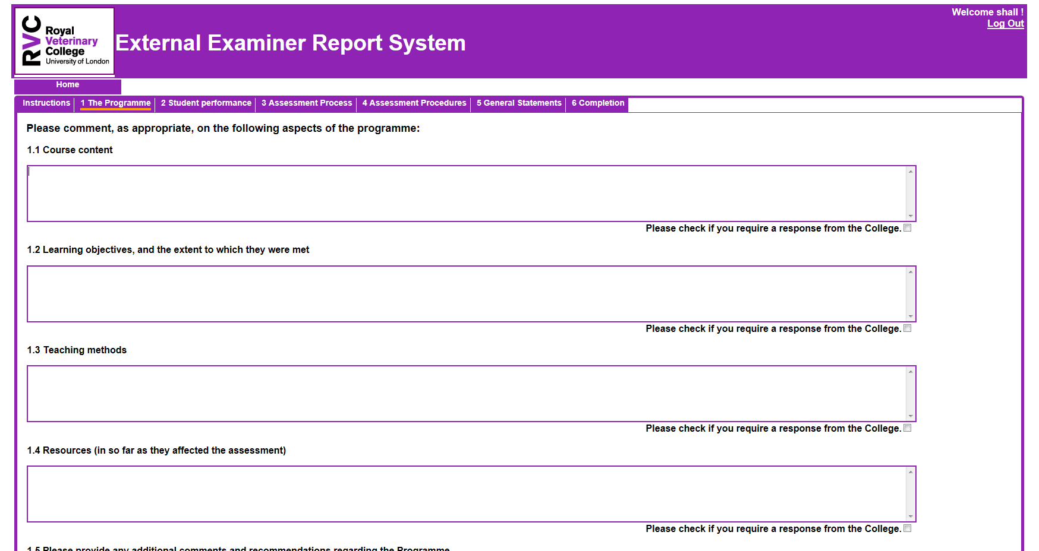

Individual Examiner – Final Page of Report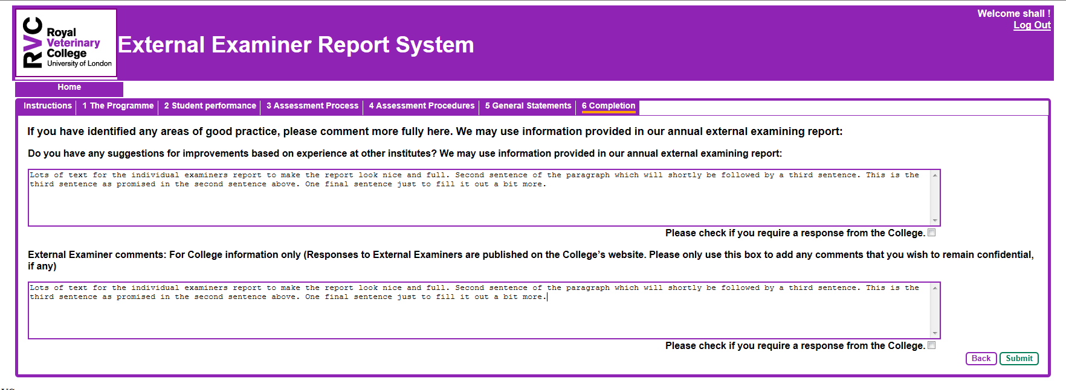
Once you have entered the report, click Submit! You will receive a pop up below!
Individual Examiner – pop up when submit button clicked! 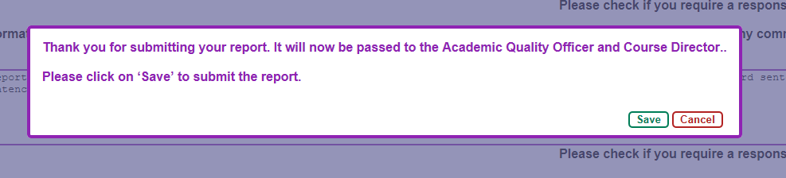
Click ‘Save’ to submit the report!

